We will be replicating the Class Schedule feature of the widely-popular USI iPhone app. The iPhone app screens appear as:
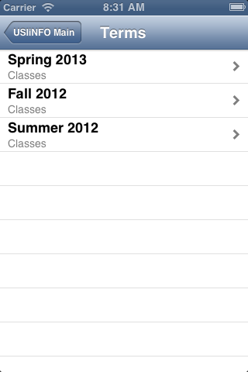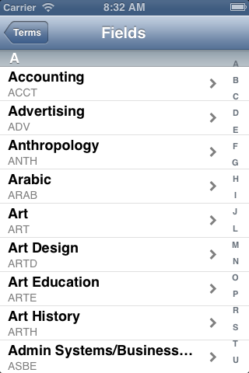

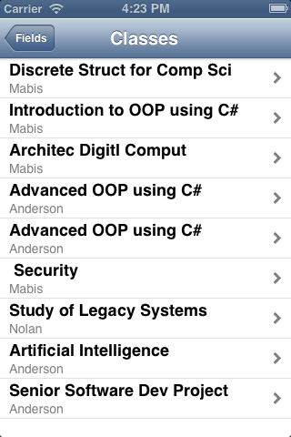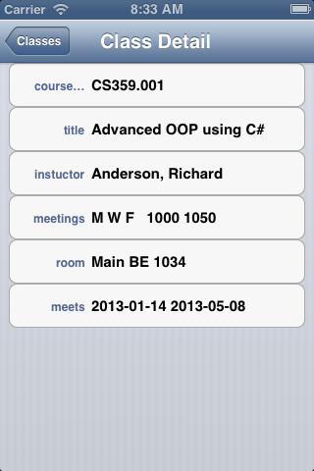

The data is available in xml files at:

http://www.usi.edu/webservices/iphone/USIINFOterms.xml
http://www.usi.edu/webservices/iphone/USIINFOterm.xml
term would be something like 201310

